Miscellaneous
Title or Task: | Hardware components System specifications  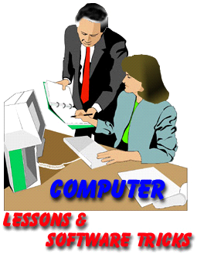

Description:

Files Required
Suitable for Classes: | AIT • Multimedia • Cert II IT • Cert II Bus
Area: | Technology & Enterprise
Teacher: | Mr Peter Faulks

Timeline

Date Due:

Task Brief:

Outcomes:

Items highlighted in yellow are tasks for you to complete
Items in Purple are help tips

Input Devices, output devices and hardware

The hardware components System specifications
The hardware components included in a computer system are often referred to as computers specifications. Users can compare the specifications of computers to judge which system may be best for particular tasks. Below is an example of a specification list for a basic computer system.
Operating System | Microsoft® Windows® XP Home Edition
Processor | Intel® Celeron® 1.7GHz
Memory | 256 MB DDR Ram
Hard Drive | 80 GB 7200rpm
CD-ROM Drive | 48x CD-ROM drive
Removable storage (Floppy disk) | 3.5in 1.44Mb Floppy Drive
Graphics Card | 128MB NVIDIA® GeForce®4
Sound Card | Sound Blaster® Audigy® 2 ZS
Speakers | Harman-Kardon® 2 piece active speakers
Keyboard and Mouse | HP® Internet Keyboard and Mouse.
Table 1: Sample specification list
Let’s have closer look the elements on the specification list.

Operating system
The operating system controls the hardware and software within a computer system. It is what you see when you first turn the computer on. Popular versions of operating systems include Microsoft® Windows® and Mac® OS. The operating systems are usually upgraded regularly, often with a name change to reflect the newest version.
Example: Microsoft® Windows® XP Home Edition
Description: The Windows® operating system is manufactured by Microsoft®. The version is the XP Home Edition.
Visit the Microsoft® website for more information. http://www.microsoft.com/windows/

Processors
If a computer was a car, the Central Processing Unit (CPU) is the engine. The speed and performance of the CPU affects the overall performance of a computer and often the type of software that it can run. Intel®, one of the most popular processor manufacturers has several versions of processors including the Celeron® and Pentium®. The Pentium® delivers better performance than the Celeron® but is more expensive.
CPU’s can be compared in terms of their clock speed. The clock speed refers to how many ‘machine cycles’ are completed every second. A ‘machine cycle’ consists of four steps:
• fetching data,
• decoding (changing the fetched data into information)
• executing
• storing information.
The number of cycles per second is measured in Megahertz (MHz) or Gigahertz (GHz). As a rule, computers with higher the clock speeds can process data faster than computers with lower clock speeds.
Example: Intel® Celeron® 1.7GHz
Description: The processor is manufactured by Intel® and is a Celeron® type processor. The clock speed is 1.7GHz
Visit the Intel® website for more information.
http://www.intel.com/

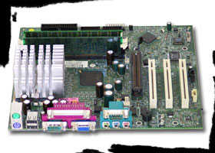

Memory
This type of memory is RAM or Random Access Memory. RAM memory is available as small sticks made up of electrical circuits which plug into the motherboard of a computer. RAM is the best known form of computer memory and is considered ‘random access’ because the processor can communicate with it directly. RAM memory is very important because it is where instructions are stored by the processor. The amount of room for instructions and the speed in which these instructions can be access by the processor determines the performance of the computer. The size of the RAM is measured in Bytes. Apart from the storage size, RAM is also available with different speeds. For people who wish to work with large graphics and video files, lots of fast RAM is required.

Example: 256 MB DDR RAM
Description: The storage size of the memory is 256 Mega Bytes. The type and speed of the RAM is DDR or Double Data Rate.
Visit the website How Stuff Works and learn more about RAM memory.
http://computer.howstuffworks.com/ram.htm

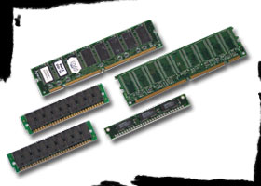

Hard Drives
The Hard Drive is the main storage device for a computer. The size of the drive determines how much data, such as programs and documents can be stored on the computer system. The size of the drive is measured in Bytes. Common hard drive sizes include 40GB (Gigabytes), 80GB and 120 GB. For working with big files such as digital video a large hard drive is required. It is not uncommon for systems to have more than one hard drive to increase storage space.

Example: 80GB 7200rpm
Description: This drive has 80GB of storage space and can spin at 7200 revolutions per minutes.

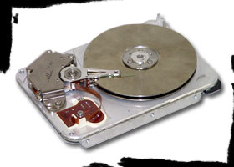

Compact Disk and DVD drives
These drives are available in a number of combinations. Some computers are sold with either a Compact Disk Drive (CD ROM) or a DVD ROM drive or both. Other packages include a combination drive which reads CD ROM and DVD. DVD stands for Digital Versatile Disk and is similar to CD ROM except it has a much larger storage capacity, about seven times as much space as a CD ROM disk.
CD ROM and DVD drives are also available with functions that allow them to write disks. This is often called burning a disk. If a drive can read and write it is identified by the addition of the letters +R (writeable) +RW (re-writable). CD ROM drives have different rates at which they can perform a read and write function, these rates are expressed as X or times.

Example: DVD+R-RW/CD ROM+R/RW combo drive
Description: This drive can read both DVD and CD ROM disks inside the one drive unit. It can write and re-write to both disk types.

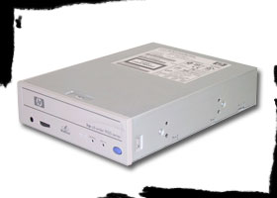

Graphics Card
A graphics card is a hardware device that is added to a computer system to improve the way a monitor displays an image. The purpose of this card is to improve the on-board graphics circuits contained on the motherboard. A graphics card has its own allocation of memory ready to process the video signal. The amount of memory and the speed of processing can affect the quality and price of the cards.

Example: 128MB NVIDIA® GeForce®4
Definition: The card is manufactured by the NVIDIA® Company and is one of their GeForce® range. It has 128Mb of memory available.

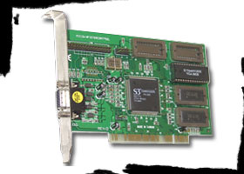

Sound Card
Similar in performance to a graphics card, a sound card improves the processing of all audio signals within a computer. The circuitry is printed onto a separate card which in turn plugs into the motherboard. The range and performance of these cards is wide and varied. A sound card can produce stereo (two speakers) or more and some can support surround sound.

Example: Sound Blaster® Audigy® 2 ZS
Definition: Sound Blaster® is the brand name with this version being from the Audigy® range.

Visit the Sound Blaster® website for more information on sound cards.
http://www.creative.com/

